RACHEL'S VINEYARD OF COLORADO 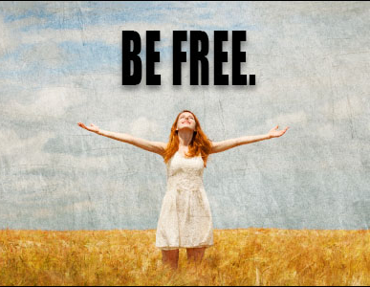
From this

To this

After abortion, the sorrow can be healed, even years later. Secrets that have never been voiced or shared can have an injurious effect on our lives. Processing a secret wound in the compassionate presence of others who have experienced the same, and in the light of God’s love and mercy, allows shame to be dispelled and creates a space in your heart and soul to receive an abundance of joy. Let go of your silence and your secret and receive consolation at a Rachel’s Vineyard Post abortion retreat and become free to be the person God created you to be.
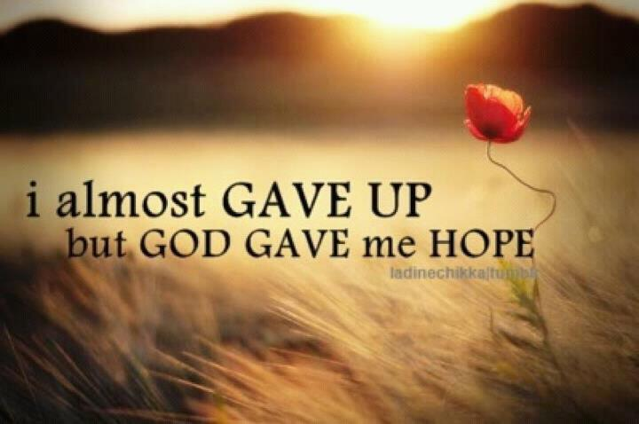
Are you struggling to mourn the loss?
Do you desire forgiveness?
Do you have loss of self-confidence?
Do you feel guilty about the decision?

You may benefit from a Rachel’s Vineyard Retreat

Call us today 303-904-7414 or 720-936-0953 www.rvrcolorado.org

These retreats are for women, men, grandparents, siblings and friends who regret helping in an abortion decision or experience the loss due to the abortion

Lori – 303-904-7414  Lfrank.rvr@gmail.com  Pam – 720-936-0953  pammysbutterfly@gmail.com  www.rvrcolorado.org | Lori – 303-904-7414  Lfrank.rvr@gmail.com  Pam – 720-936-0953  pammysbutterfly@gmail.com  www.rvrcolorado.org | Lori – 303-904-7414  Lfrank.rvr@gmail.com  Pam – 720-936-0953  pammysbutterfly@gmail.com  www.rvrcolorado.org | Lori – 303-904-7414  Lfrank.rvr@gmail.com  Pam – 720-936-0953  pammysbutterfly@gmail.com  www.rvrcolorado.org | Lori – 303-904-7414  Lfrank.rvr@gmail.com  Pam – 720-936-0953  pammysbutterfly@gmail.com  www.rvrcolorado.org

